Weekly Updates 10/14/16
Samuel Archibald
Alan Lukas
SMART Forest and IoT Sensor Projects

Lab and Personal Update-

Due to a lot of stuff that happened at home, Sam's ability to work was removed for a few weeks. Now he is able to work again. In the lab, Alan and Sam have worked in PCB manufacture, manufacturing PCBs for the EPI device they designed over the summer.

Project Updates-

A couple weeks ago the first prototype came in. It is yet to be tested but is pictured below. When finished, it will be capable of communicating with another device up to one and a half miles away. It is capable of having many wired sensors connected and will be the template for all future boards.
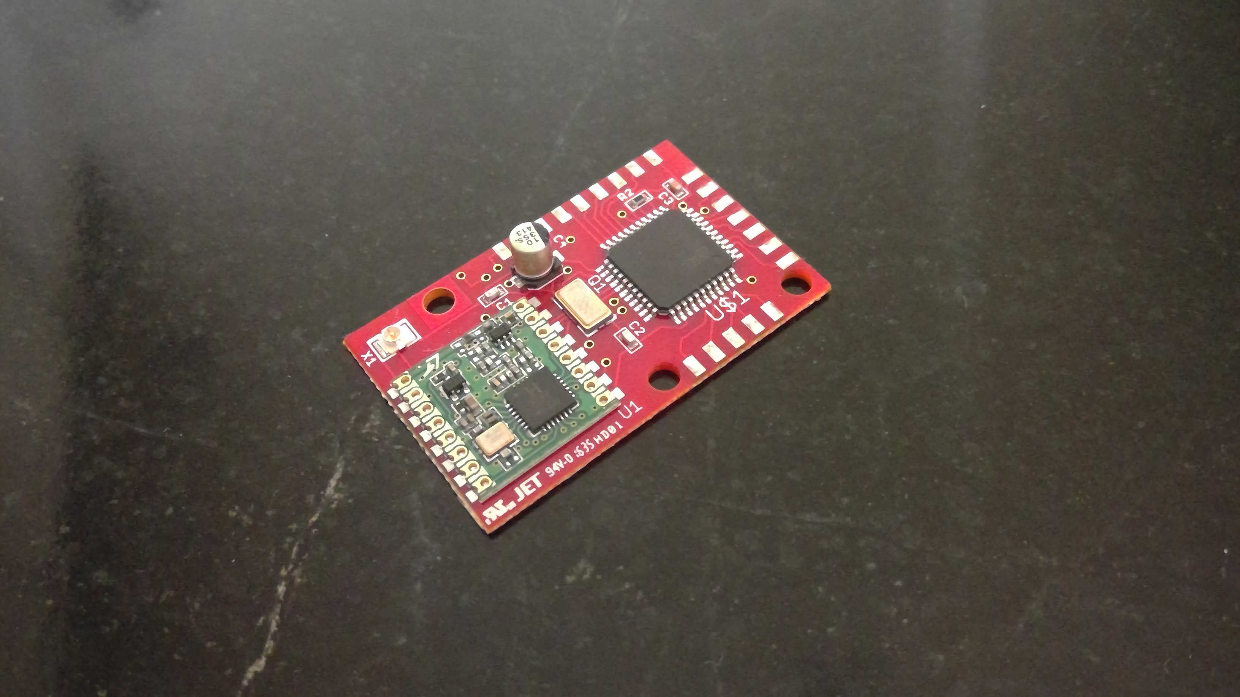

Attached is also the first draft of the concept sheet for the IoT devices with the form concept. When the specifications are gathered in the future, we will be able to make a similar document for the SMART Forest project.

Using satellite photography, we found the wooded area near the Gorham USM campus is well sized for the project as all units will be able to communicate with each other without any range extending units. We've also been looking into making the sensors as self reliant as possible with a solar panel and good battery life.

We will also be looking for students to help with the project over the course of the next couple weeks. Including computer science students, and a environmental student.

